## **Purvi - Movielens Challenge SQL**

### **List the titles and release dates of movies released between 1983-1993 in reverse chronological order.**

SELECT title, release_date

FROM movies

WHERE release_date BETWEEN '1983-01-01' AND '1993-01-01'

ORDER BY release_date DESC;

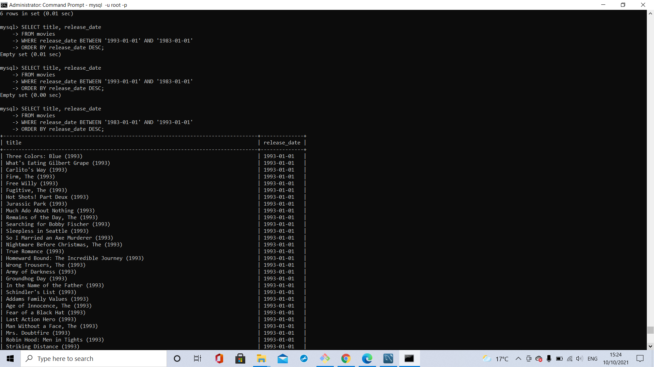

### **Without using LIMIT, list the titles of the movies with the lowest average rating.**

SELECT title, AVG(rating) AS average_rating

FROM movies

JOIN ratings ON movies.id = ratings.movie_id

GROUP BY movies.title

HAVING average_rating = (

SELECT MIN(avg_rating)

FROM (

SELECT AVG(rating) AS avg_rating

FROM ratings

GROUP BY movie_id

) AS table1

)

ORDER BY average_rating;

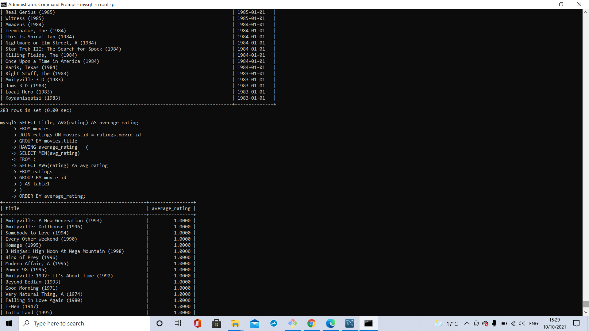

### **List the unique records for Sci-Fi movies where male 24-year-old students have given 5-star ratings.**

SELECT movies.id, title

FROM movies

JOIN genres_movies ON genres_movies.movie_id=movies.id

JOIN genres ON genres.id=genres_movies.genre_id

JOIN ratings ON ratings.movie_id=movies.id

JOIN users ON users.id=ratings.user_id

JOIN occupations ON occupations.id=users.occupation_id

WHERE genres.name='Sci-Fi'

AND users.age='24'

AND users.gender='m'

AND ratings.rating='5'

AND occupations.name='Student';

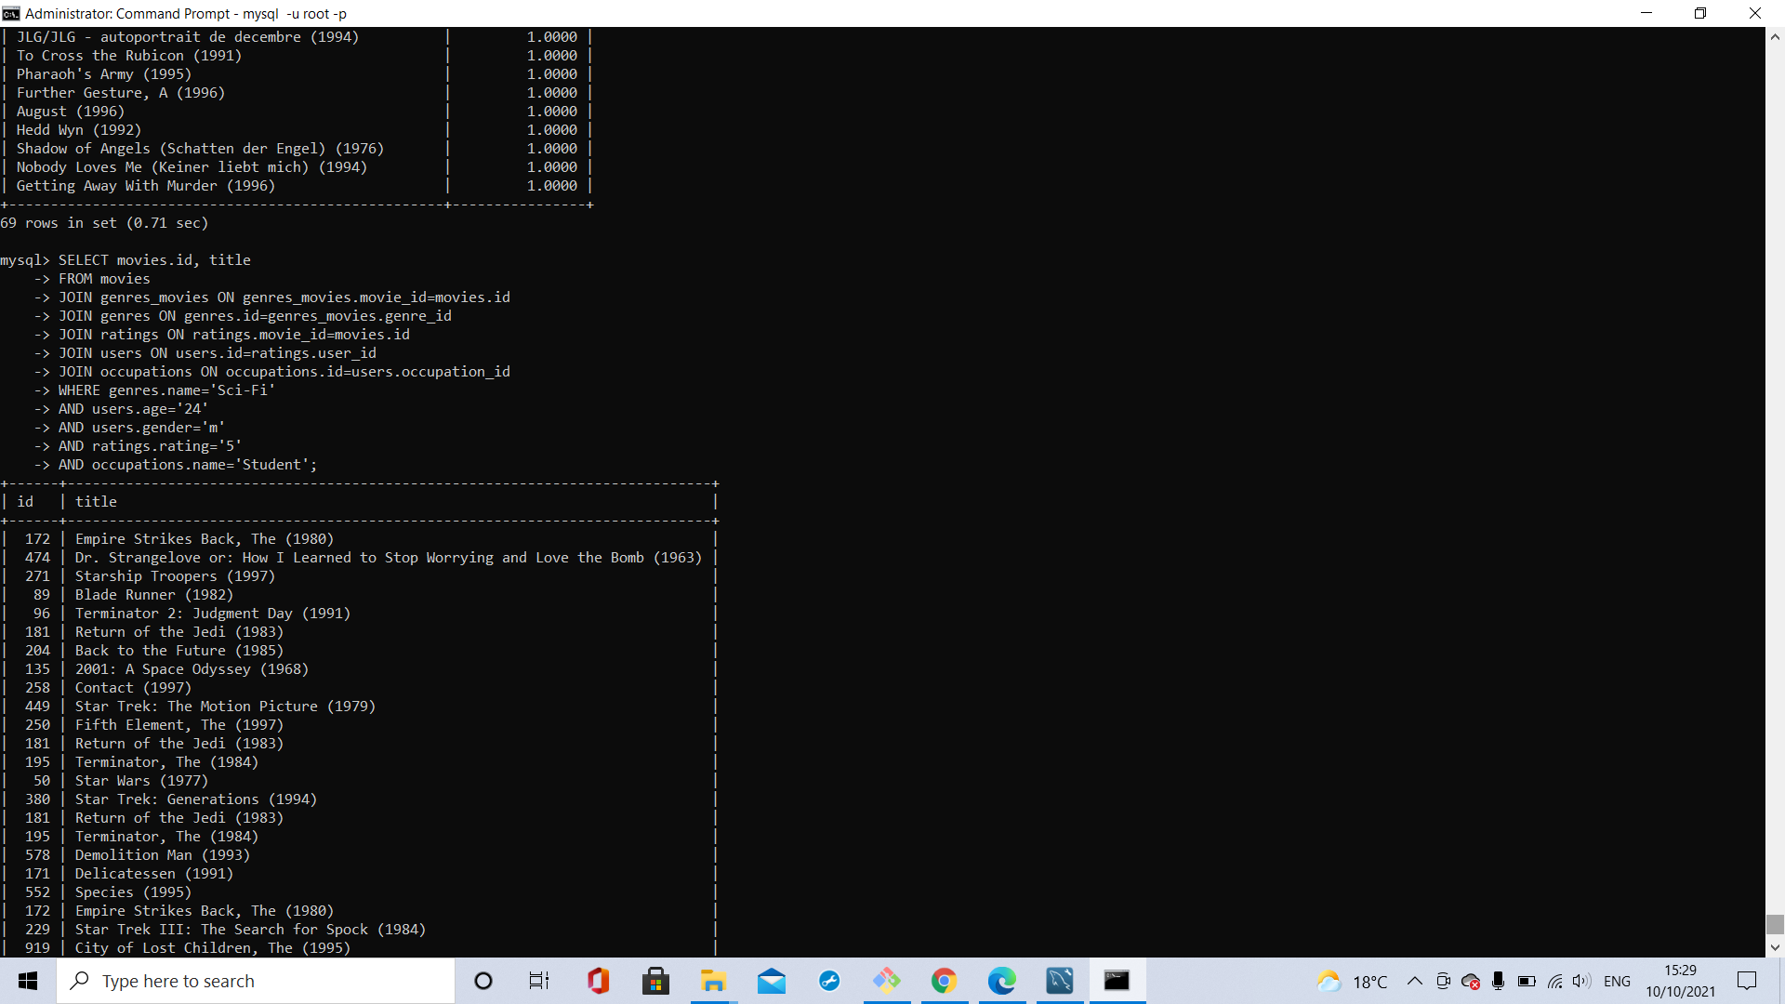

### **List the unique titles of each of the movies released on the most popular release day.**

SELECT title

FROM movies

WHERE release_date=(

SELECT release_date

FROM movies

GROUP BY release_date

ORDER BY COUNT(id) DESC

LIMIT 1);

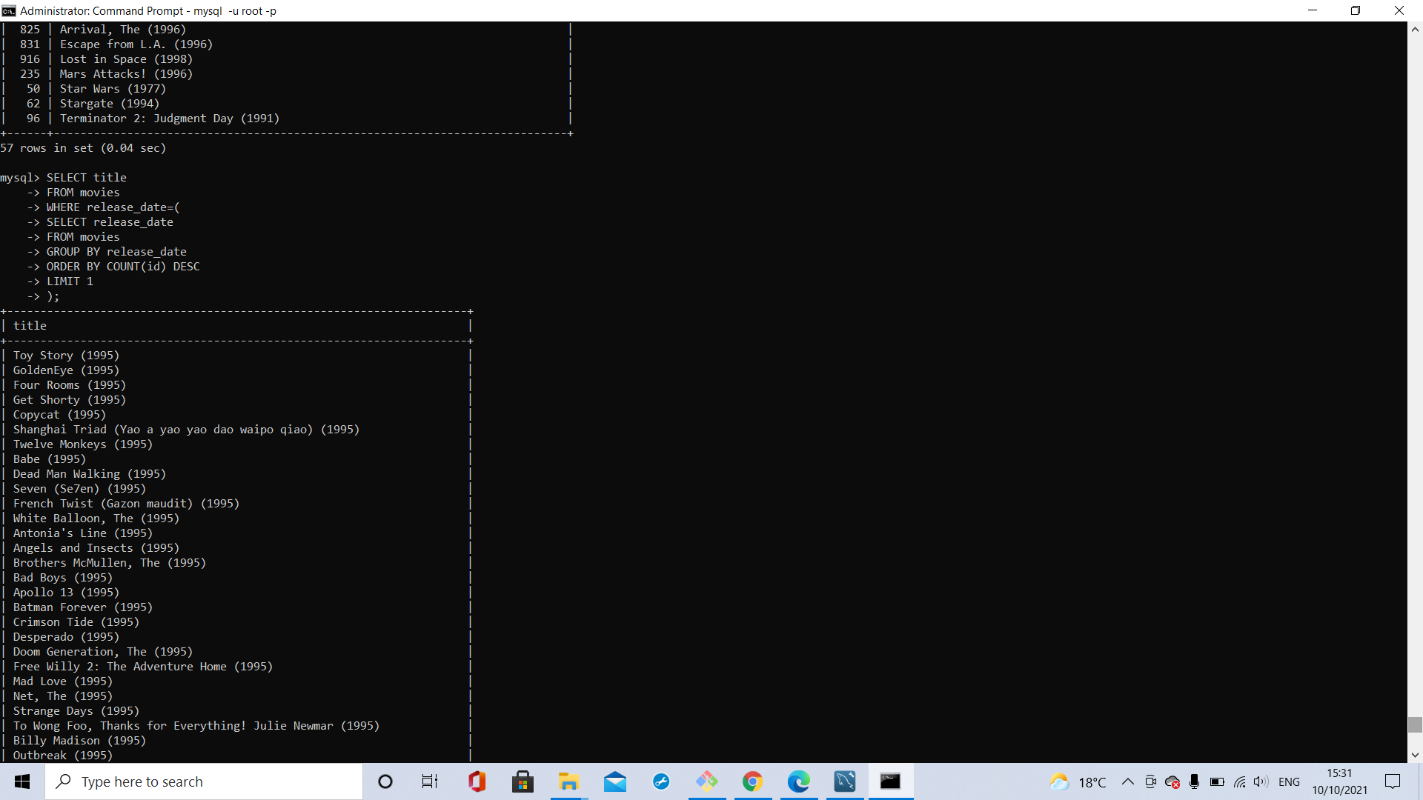

### **Find the total number of movies in each genre; list the results in ascending numeric order.**

SELECT COUNT(movies.id), genres.name

FROM genres

JOIN genres_movies ON genres.id=genres_movies.genre_id

JOIN movies ON genres_movies.movie_id=movies.id

GROUP BY genres_movies.genre_id

ORDER BY COUNT(movies.id) DESC;

